1. Overview
Before you continue filling out your game design document (GDD), it helps to step back and ask, “What is game design, exactly? And how is it different from simply using Unity and C# to build a game?”
In this lab, you'll learn to do the following:
- Explain what game design is and how it differs from game development
- Break down a game into core building blocks: goals, rules and mechanics, challenge, and feedback
- See how game design elements come together in a core loop and to form the player experience
- Practice deconstructing a simple game
- Fill out related parts of your GDD
You’ll do a few reflection exercises along the way, using either games you already know or your own project idea.
2. Game design vs. game development
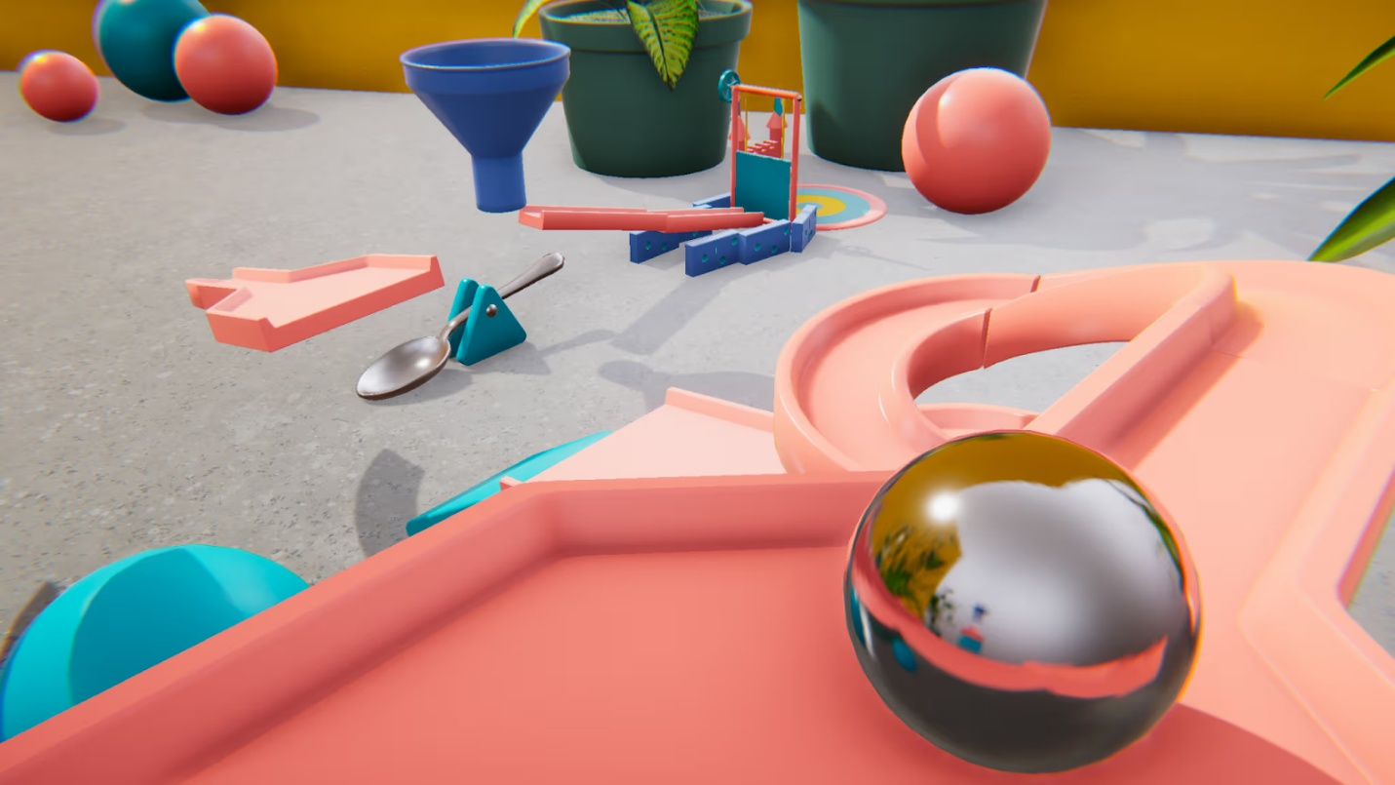
Game design and game development are tightly connected, but they’re not the same job.
- Game development is the work of implementing a game: scripting in C#, setting up scenes and prefabs, importing art and audio, building and publishing your project.
- Game design is the craft of deciding how the game actually plays: its rules, systems, pacing, and the experiences you want players to have.
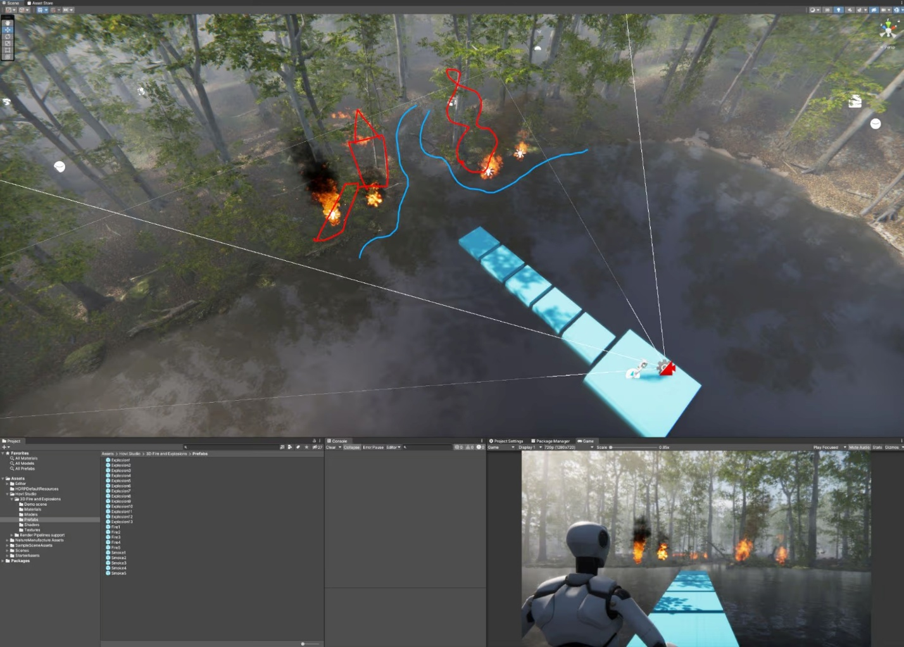
As a game designer, you think about the following questions:
- What is the player trying to achieve?
- What are they allowed to do, and what are they not allowed to do?
- What stands in their way?
- How hard should it be to succeed?
- How should this feel to play?
As a developer, you use Unity tools to make those design decisions real in a playable build.
However, the line between design and development isn't always clear-cut, and in small teams or solo projects, you'll often wear both hats simultaneously. Some developers are also excellent designers, and vice versa. Think of these as different modes of thinking rather than rigid job roles.
Design is also iterative. You rarely get everything right on the first try. Designers and developers expect to tweak rules, difficulty, and systems as they prototype, playtest, and respond to players’ feedback.
Reflection exercise: design decisions in real games
Pick a simple game you know — ideally something with clear, observable mechanics rather than a complex RPG or strategy game. Mobile games, arcade classics, or simple indie games work well for this exercise. If you can’t think of one, use a classic example like Pac-Man or Tetris.
Try to think of one decision that feels like a design choice in the game: something that was intentionally decided that affected the design of the game.
Here are a few examples to get you thinking:
- You lose most of your progress when you die, but keep a few upgrades (common in roguelikes)
  - A Roguelike is a subgenre of role-playing video games defined by procedurally generated levels, turn-based movement on a grid, and permanent death
- There are generous checkpoints before each boss
- You can only carry two weapons at a time
- You always respawn close to the last puzzle you failed
You can spot choices like these in popular, complex Unity games:
- Hollow Knight uses limited healing and distant benches to change how risky exploration feels.
- Human: Fall Flat uses intentionally imprecise, physics-based controls that turn frustration into humor, and makes mastery part of the fun.
- Ori and the Blind Forest ties ability unlocks to story moments. This makes progression feel emotional rather than purely mechanical.
These are all design decisions. They’re implemented with code, but they fundamentally shape the player’s experience.
3. Core ingredients of game design
Most games, no matter how different they look, share a small set of fundamental elements. Understanding these will make it easier to both design your own games and analyze others.
Think of this section as the main ingredients before they’re mixed together in a game.
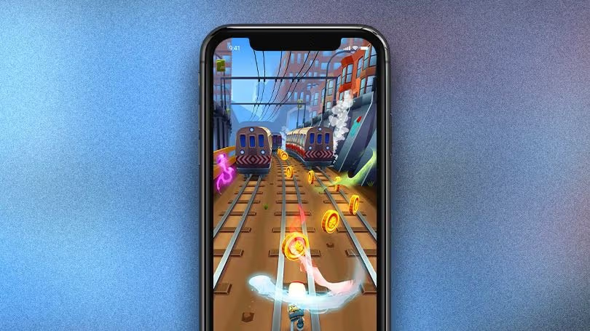
Image from Subway Surfers case study.
1. Player goal
Every game needs at least one clear goal.
Ask
What is the player trying to achieve?
Examples
- Survive as long as possible (2D Sprite Flight game)
- Collect all the gems (3D Roll-a-Ball game)
- Reach the end of the level
- Defeat all enemies in an arena
- Build a successful city, farm, or theme park
- Solve each puzzle in a region
If the goal is unclear, players often feel lost or unfocused.
2. Rules and mechanics
You can group rules and mechanics together.
- Mechanics are the actions available to the player.
- Rules are the logic and constraints that define how those actions work.
Ask
- What can the player do?
- What can they not do?
- When they do something, what exactly happens?
Examples
- Movement mechanics and rules:
  - You can move in 8 directions (3D Roll-a-ball Game).
  - You can jump, and if you press jump again in mid-air you double-jump.
- Combat mechanics and rules:
  - You can attack and block.
  - Enemies take 3 hits to defeat.
- Strategy mechanics and rules:
  - You can place towers, but not within a certain radius of the path.
  - Each tower placement costs resources that regenerate slowly.
When you think, I’m going to code WASD movement, double jump, and a dash, you’re talking about mechanics and rules.
3. Challenges and obstacles
Challenges are what stand between the player and their goal: the obstacles they need to overcome.
Ask
- What makes it non-trivial to reach the goal?
Examples
- Enemies that chase or shoot the player (3D Roll-a-Ball game)
- Tight spaces or hazards (2D Sprite Flight game)
- Moving platforms, gaps, and tricky jumps
- Limited health, ammo, or time
- Competing players in a multiplayer game
Without conflict or challenge, there may be less traditional gameplay. However, many designers debate where to draw the line between games, sandboxes, and interactive experiences. Games like Journey show that meaningful play doesn't always require explicit conflict. For this lab, we're focusing on challenge-based games, which are more straight-forward when you’re getting started.
4. Feedback
Feedback is how the game responds when the player does something. It tells them the following:
- What just happened
- Whether it was good, bad, or neutral
- Whether they should do more of that thing
Examples
- Visual feedback:
  - Animations and particle effects when you take damage or collect an item (2D Sprite Flight game)
  - Screen flash or shake for big hits or explosions
- Audio feedback:
  - Sound effects for jumping, hitting, scoring, or failing
  - Music that changes as tension rises (for example, in a boss fight)
- UI feedback:
  - Health bars, score counters, combo meters, timers
  - “You win!” or “Game Over” screens (3D Roll-a-Ball game)
  - Objective markers and progress bars
Good feedback is clear and timely. The player should not have to guess whether they succeeded or why they failed.
Mark step complete
4. Case study: Subnautica
As an example, let’s look at those ingredients working together in Subnautica, an underwater survival game made with Unity. You can find it here: Subnautica on Steam.

Exercise
If you’re not familiar with Subnautica, watch the trailer above and read the description on Steam. Do your best to identify the player goal, rules, mechanics, challenge, obstacles, and feedback. Then continue reading on to see how your answers compare.
- Player goal:In Subnautica, your immediate goal is to survive after crash-landing on an alien ocean planet. You must manage food, water, and oxygen. Your long-term goal is to uncover the planet’s mysteries and ultimately escape.
- Rules and mechanics:You must manage an oxygen meter whenever you dive, gather resources from the seafloor, and use crafting stations to build tools, vehicles, and bases.
- Challenges and obstacles:Challenges come from hostile wildlife, dangerous biomes, and environmental limits.
- Feedback:Subnautica uses the following feedback to keep you informed:
  - UI meters show oxygen, health, and hunger
  - Warning sounds and voice lines play when resources are low or equipment is damaged
  - Visual effects like red flashes and suit alarms when you’re hurt or running out of air
  - Ambient audio and music shifts as you move into deeper, more dangerous zones
Mark step complete
5. Fill out the Core Design Elements section of your GDD
Now that you have an understanding of these game design ingredients, fill out the 2 - Core Design Elements table of your GDD, including the following sections:
- Player goal
- Rules and Mechanics
- Challenge / Obstacles
- Feedback
Mark step complete
6. Putting it together: core loop, difficulty, player experience, and game feel
The previous section described the ingredients of game design. Now we’ll look at how they combine into the player’s moment-to-moment experience.
We’ll focus on three ideas:
- The core loop (what players repeatedly do)
- Difficulty (how demanding it is)
- The overall player experience and game feel
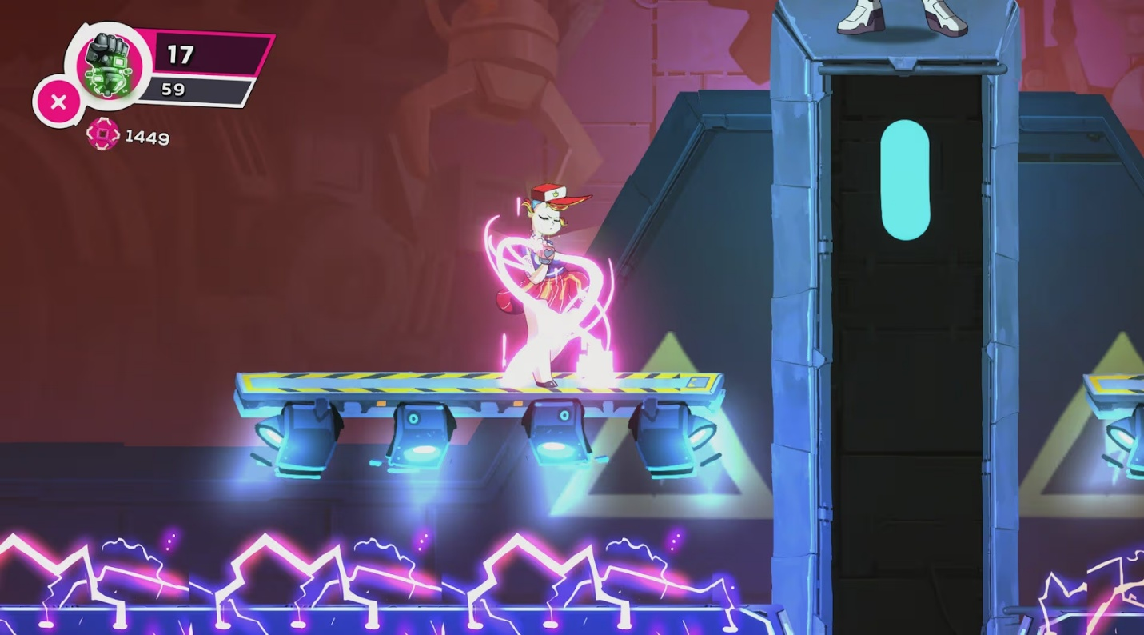
Core loop
The core loop is the sequence of actions the player repeats most of the time. It’s the backbone of your gameplay.
Ask
- What does the player do over and over?
Examples
- Arcade-style:
  - Move → Collect pick-up → Score → Repeat
- Action-RPG:
  - Explore → Fight → Loot → Upgrade → Repeat
- Tower defense:
  - Place towers → Watch enemies → Earn currency → Place more towers → Repeat
- Spell-based combat:
  - Cast spells → Manage mana → Defeat enemies → Collect rewards → Repeat
In game development projects, you often implement the core loop first. Then you layer audio, visuals, and extra systems on top.
Difficulty
Difficulty is how demanding your game feels to play. Even if the goal and obstacles stay the same, you can tune difficulty up or down by changing numbers, timings, and penalties.
Here are some examples of how you might adjust difficulty:
Jumping across moving platforms
- Easier: Platforms move slowly, gaps are small, and missing a jump only sends you back a short distance.
- Harder: Platforms move quickly, gaps are wider, and falling sends you back to the start of the level.
Defeating a boss
- Easier: The boss has low health, attack patterns are simple and clearly telegraphed, and healing items are plentiful.
- Harder: The boss has more health, attacks chain together quickly, and the arena includes extra hazards.
A difficulty curve is how difficulty changes over time, designed to keep players engaged without becoming bored or frustrated. Most games start easier so you can learn the mechanics, then gradually introduce tougher enemies, tighter timings, or more complex patterns as you improve.
As you design a game, think about the following:
- How hard you want the first few minutes to feel
- When and how you’ll increase difficulty
- Whether players have options to make the game easier or harder (for example, difficulty modes or assist options)
Player experience and game feel
The player experience is what it feels like — emotionally — to play your game. You can aim for feelings like the following:
- Relaxed and cozy
- Tense and focused
- Clever and satisfied
- Powerful and dominant
- Chaotic and silly
Game feel is how the game responds to input and how it feels to control.
Game feel depends on things like the following:
- How quickly the game responds to input (input lag vs snappy controls)
- How movement accelerates and decelerates
- How animations and sounds line up with actions
- How strong visual feedback is (for example, subtle vs huge screen shake on impact)
Small changes to speed, animation timing, camera movement, and audio can dramatically change how "tight" or "floaty" a game feels — even if the mechanics and rules stay the same.
Note: Game feel is one of the hardest aspects of design to teach or learn from text alone. For deeper understanding, check out Game Feel by Steve Swink, or search for "juice" and "game feel" video labs that show before/after comparisons.
Case study: Among Us
You can see these ideas played out in Among Us, a social deduction game made with Unity. You can find it here: Among Us on Steam.
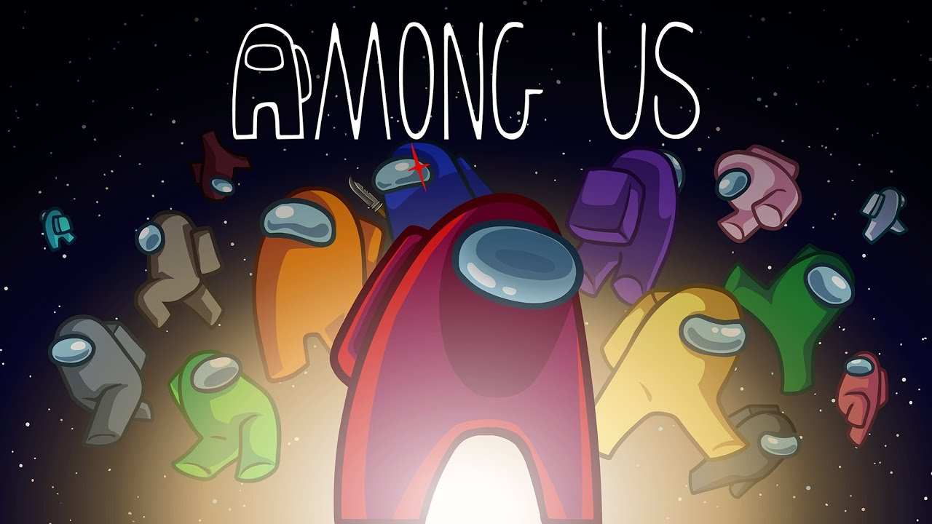
Exercise
If you’re not familiar with Among Us, watch the trailer above and read the description on Steam. Do your best to describe the core loop, changes in difficulty, player experience, and game feel. Then continue reading on to see how your answers compare.
- Core loop: Move around the map → do or fake tasks → react to bodies or emergencies → discuss and vote → repeat.
- Difficulty: Difficulty in Among Us isn’t about precision platforming or combat; it’s about social and informational difficulty. You can tune it by changing lobby settings: how many impostors there are, how fast players move, how much vision they have, how complex the tasks are, and more. Small changes to these numbers can make it much easier or much harder to correctly read other players and survive.
- Player experience: The player experience is designed to feel tense, but often funny. Short emergency meetings and limited discussion time force you to make fast accusations and defenses under pressure, while the mix of silly animations and simple art keeps the tone light.
- Game feel: Even though the controls are simple (click to move, use buttons for tasks and sabotages) Among Us uses clear UI prompts, sound effects (like the emergency meeting alarm or kill sound), and quick, punchy animations (such as the dramatic kill cutscenes) to make interactions feel snappy and impactful.
Optional step
7. More Game Design resources (optional)
This lab covered foundational game design concepts to get you started. If you’re interested in exploring Game Design more deeply to continue developing your skills, here are some recommended resources:
Books
- The Art of Game Design: A Book of Lenses by Jesse SchellThe most comprehensive introduction to game design. Each lens is a different way to analyze your game.
- Level Up! The Guide to Great Video Game Design by Scott RogersA practical, approachable guide packed with real-world examples and hands-on advice. Excellent for understanding how to move from concept to playable game, with lots of visual examples.
- Game Feel: A Game Designer's Guide to Virtual Sensation by Steve SwinkThe definitive book on game feel, juice, and polish.
Videos
- Game Maker's Toolkit (YouTube) Mark Brown's video essays analyze design decisions in popular games.
- GDC Vault (Free talks available)Recordings of Game Developers Conference presentations. Search for talks on topics you’re interested in.
Mark step complete
8. Next steps
In this lab, you learned how game design differs from game development and explored how designers shape player experiences through goals, rules, mechanics, challenge, feedback, and difficulty. You also practiced breaking down a simple game and filled out the next section of your GDD.
Next, you’ll zoom out to look at game genres, the common actions (“verbs”) that define them, and how platforms, hardware, and context of play influence your design choices.

